**CST-117**

**Exercise 9**

**Objectives:**

* Utilize a variety of debugging techniques to locate and correct errors

**Essential Reading:** Chapter 6 from your textbook.

**Activity Directions:**

Run the following console application (code provided). This program should produce the union of two sets, but has several errors. Use a variety of debugging techniques to locate and correct the errors.

NOTE: A set is a collection of like elements that does not contain any duplicates. The union of two sets is the set that contains all the elements in both sets. Formally:

A union B = {x : x ∈ A or x ∈ B}  
*read: A union B is the set of all x such that x is in A or x is in B*

Example: A = {1,2,3,4,5} and B = {2,4,6,8}, then A union B = {1,2,3,4,5,6,8} (notice, no duplicates!)

Debug the program. When you find an error, comment out the offending line, give an explanation of the error, and write a corrected line. For example, say you have a program with the following:

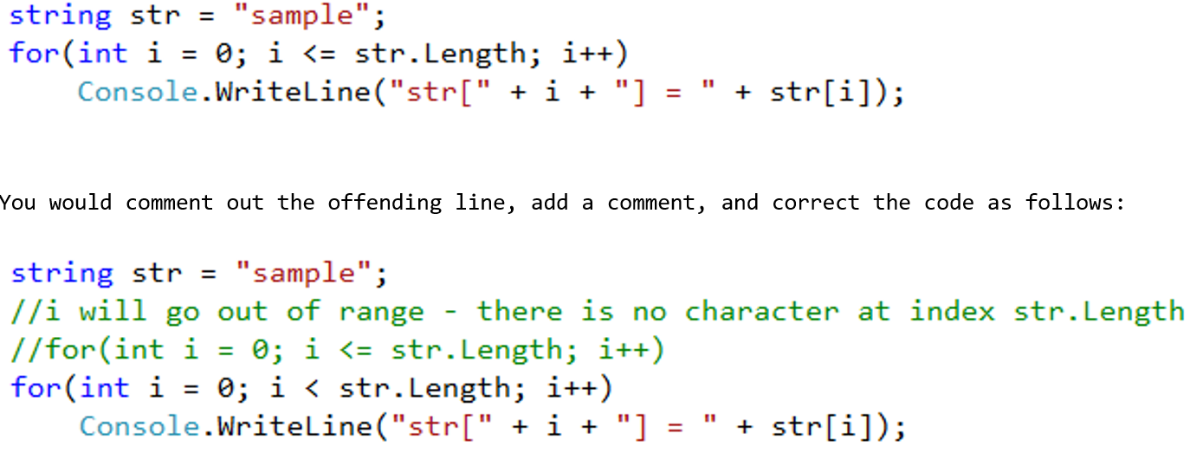

Submit the modified files and screen shots of any breakpoints you use. Include your name at the top as shown here:

//Corrected by Caleb Miller

Apart from the debugger telling me things were wrong, I could not fix what it was telling me was wrong. I messed around with some things but couldn’t get it to debug.

